**VISVESVARAYA TECHNOLOGICAL UNIVERSITY**

**Jnana Sangama, Belagavi-590018, Karnataka**



**An AICTE Activity Report**

*Submitted in partial fulfillment of the requirements for the award of degree of Bachelor of Engineering in*

**COMPUTER SCIENCE AND ENGINEERING** (**DATA SCIENCE)**

**Submitted by**

**CHAITHANYA L (1MJ20CD045)**

**AICTE Activity Report**

***carried out at***

Government Higher Primary School, Channasandra



**MVJ COLLEGE OF ENGINEERING, BENGALURU - 560067**

**(Autonomous Institution Affiliated To VTU, Belagavi)**

**Academic Year 2024-2025**

Sensitivity Label: Personal Data



**MVJ COLLEGE OF ENGINEERING, BENGALURU- 560067**

**(Autonomous Institution Affiliated To VTU, Belagavi)**

**DEPARTMENT OF COMPUTER SCIENCE AND ENGINEERING (DATA SCIENCE)**

# CERTIFICATE

This is to certify that the AICTE activities**,** entitled “Swachh Bharat”, “Skill Development**”,** “Distribution of Essentials to Students”, “Tourism Promotion”, “ Women Empowerment” and “100% Digitalized Money Transactions”**,** are the Bonafide work carried out by

NAME: CHAITHANYA L USN:1MJ20CD045

In partial fulfillment for the award of degree of Bachelor of Engineering in COMPUTER SCIENCE AND ENGINEERING (DATA SCIENCE) of the Visvesvaraya Technological University, Belagavi during the academic year 2024-25 at Government Higher Primary School, Channasandra, Government Higher Primary School, Khazimakan Hosakote Town and Vishveshwarapura PU college from **12/12/2021 to 18/12/2021, 1/05/2022 to 22/05/2022, 11/07/2022 to 24/07/2022, 22/08/2022 to 04/09/2022, 08/03/2025 to 22/03/2025 and 05/04/2025**

**to 19/04/2025** respectively for the above mentioned AICTE activities, each spanning 2 weeks. It is certified that all the corrections/suggestions indicated have been incorporated in the report. The activity report has been approved as it satisfies the academic requirements.

**AICTE COORDINATOR Signature of HOD**

Sensitivity Label: Personal Data

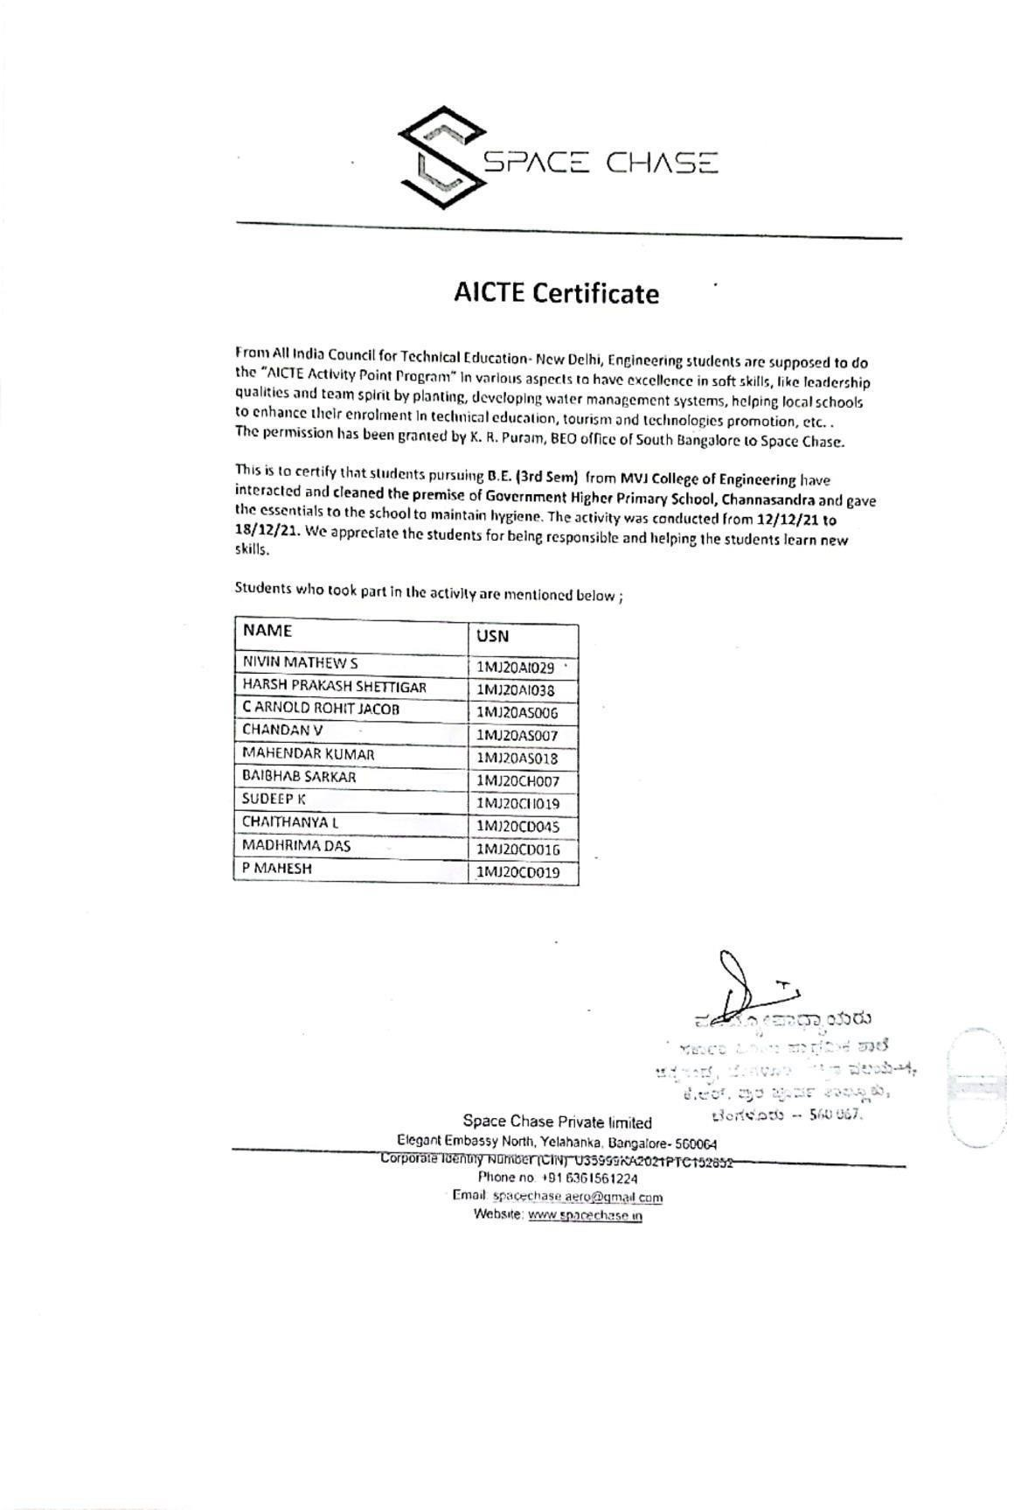

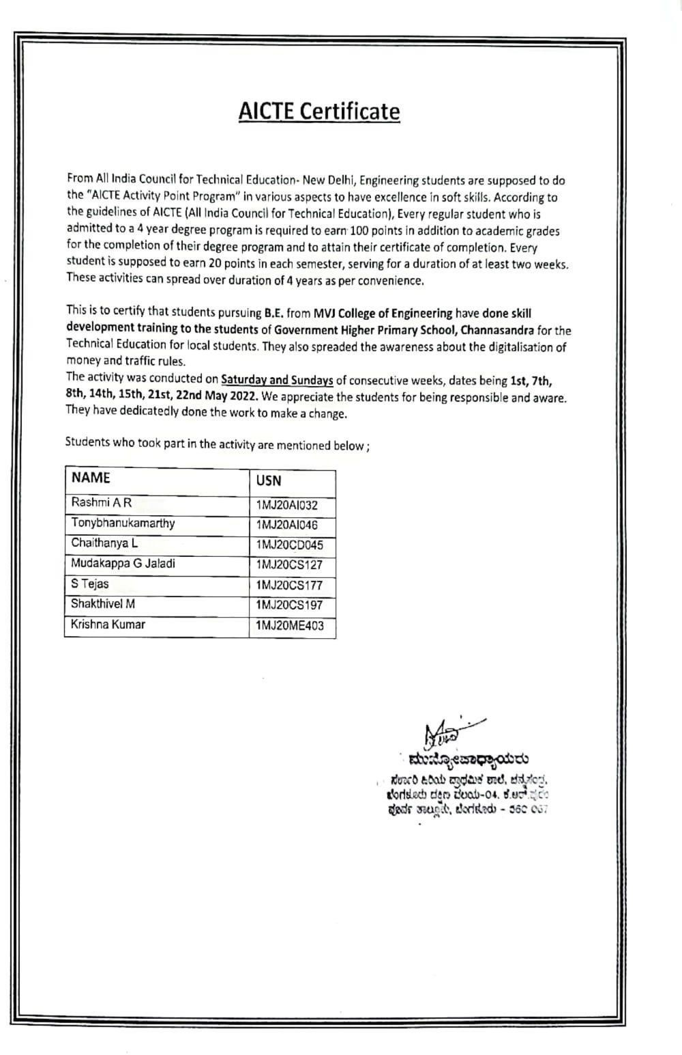

Sensitivity Label: Personal Data

Sensitivity Label: Personal Data

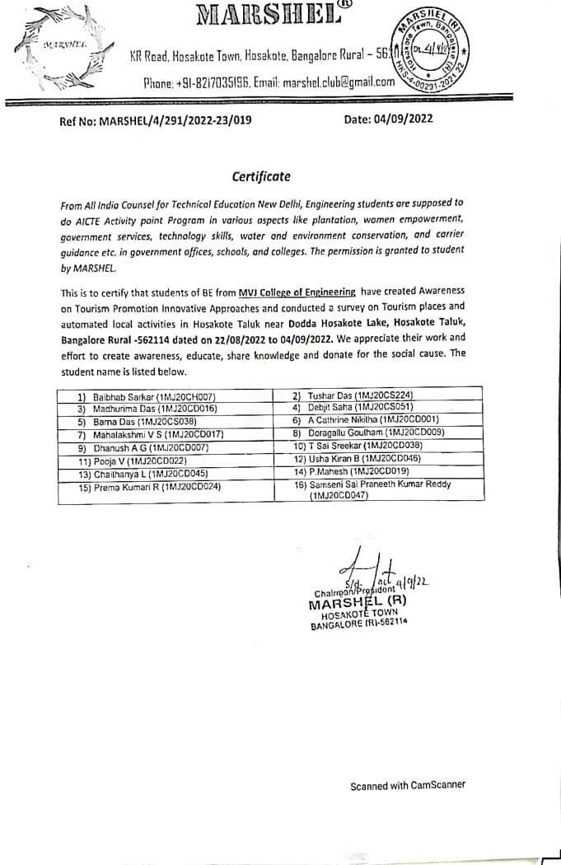

Sensitivity Label: Personal Data

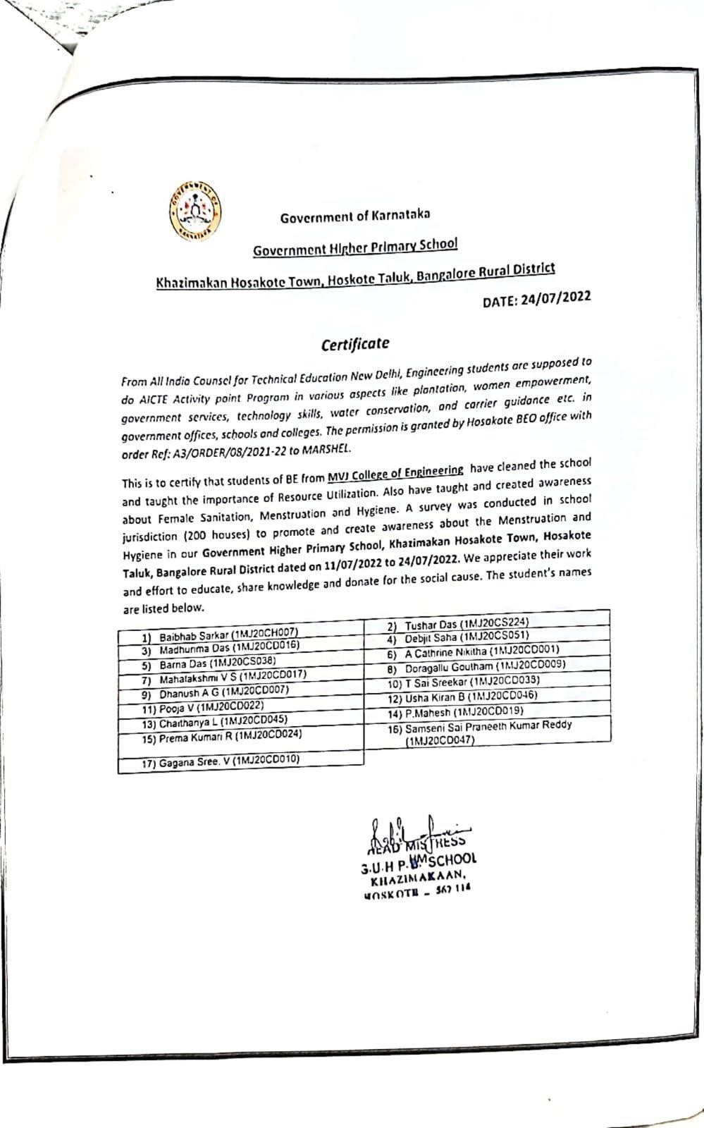

Sensitivity Label: Personal Data

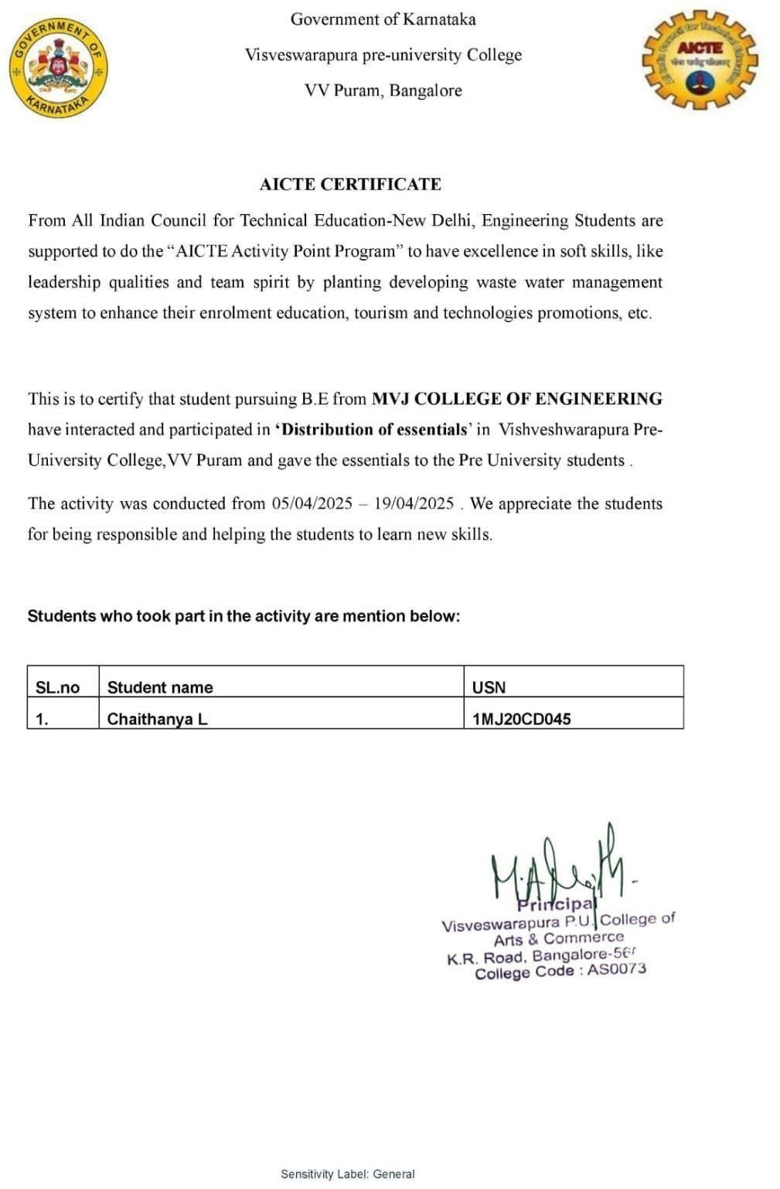

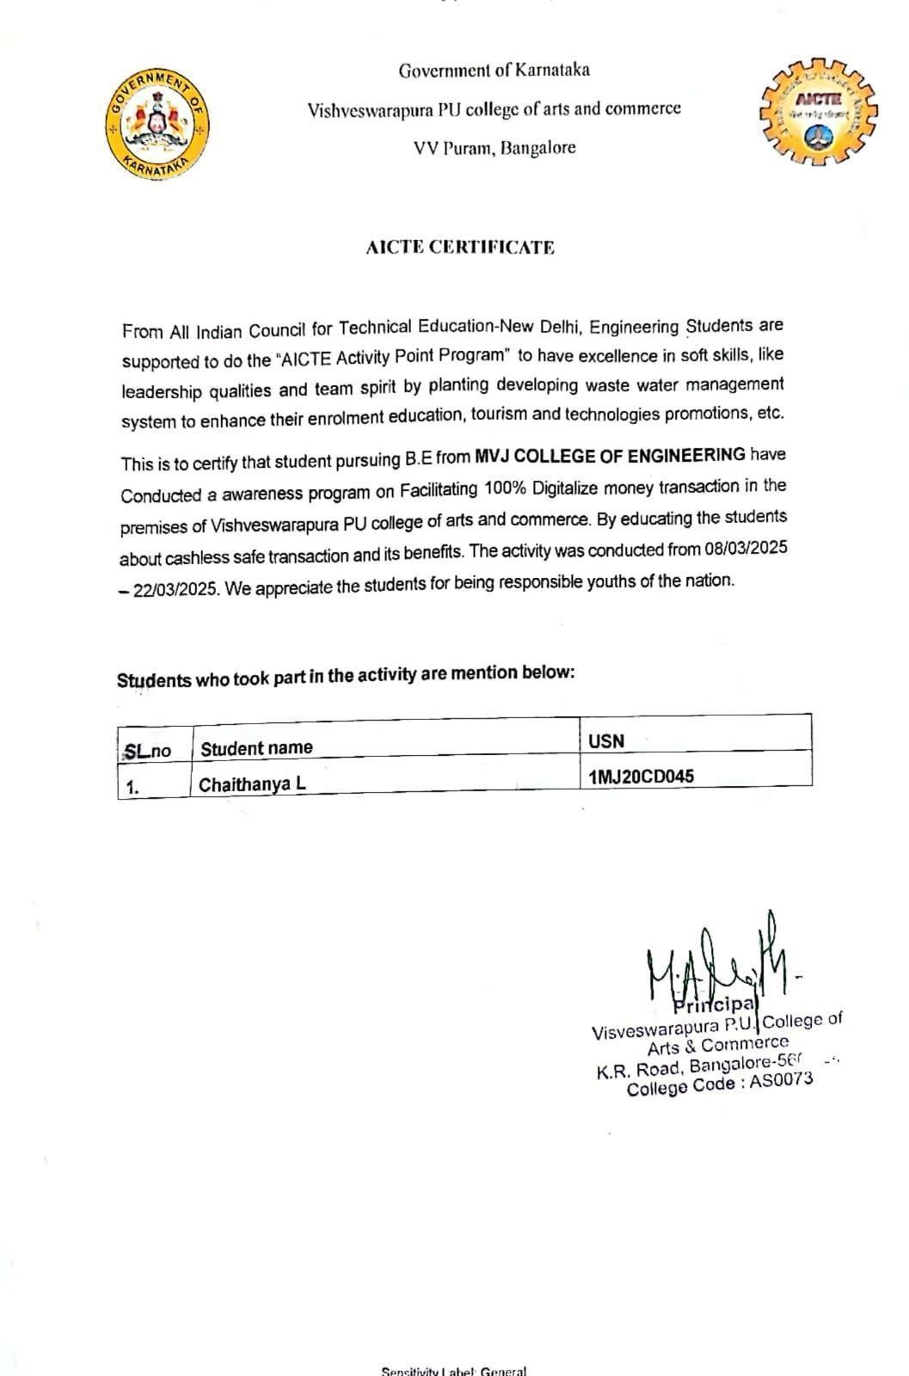



**MVJ COLLEGE OF ENGINEERING, BENGALURU- 560067**

**(Autonomous Institution Affiliated To VTU, Belagavi)**

**DEPARTMENT OF COMPUTER SCIENCE AND ENGINEERING (DATA SCIENCE)**

# DECLARATION

I, CHAITHANYA L, 1MJ20CD045 hereby declare that the entire activity **,** entitled “Swachh Bharat”, “Skill Development**”,** “Distribution of Essentials to Students”, “Tourism Promotion”, “ Women Empowerment” and “100% Digitalized Money Transactions” embodied in this report has been carried out by me at Government Higher Primary School, Channasandra from 12/12/2021 to 18/12/2021, 1/05/2022 to 22/05/2022, 11/07/2022 to 24/07/2022, 22/08/2022 to 04/09/2022,

08/03/2025 to 22/03/2025 and 05/04/2025 to 19/04/2025 respectively for the above mentioned AICTE activities. The work embodied in this report is original and it has not been submitted in part or full for any other degree in any University.

Place: MVJCE, Bengaluru Date:

**Name Signature**

**CHAITHANYA L (1MJ20CD045)**

# TABLE OF CONTENTS

**Certificate ll**

**Declaration Vlll**

**Table Of Contents IX**

**List Of Figures X**

|  |  |  |
| --- | --- | --- |
| Chapter No. | Chapter Name | Page No. |
| 01  02  03  04  05  06 | Swachh Bharath Skill Development Tourism Promotion  Women Empowerment Distribution of Essentials  100% Digitized Money Transaction | 1  7  12  17  23  29 |

x

# LIST OF FIGURES

Swachh Bharath 2024-2025

|  |  |  |
| --- | --- | --- |
| **Figure No** | **Figure Name** | **Page No** |
| 1.1  2.1  3.1  4.1  5.1  6.1 | Cleaning of School Premises Skill Development To Students Survey on Tourism Promotion  Creating Awareness on Mensuration and Hygiene Distribution of Essentials to Students  Creating Awareness about 100% digitized money transaction | 4  9  13  18  23  29 |